**ONLINE BOOK SELLING MANAGEMENT SYSTEM**

**CASE STUDY OF CHARISMA BOOKSTORE.**

**BY**

**UWAMAHORO JACKY**

**BBIT/14/03/0786**

**Research proposal submitted in partial fulfillment of the requirement for the award in Bachelor of Science in Business Information Technology (BBIT) submitted to school/Faculty I.T and Architecture, University of Kigali.**

**December (2017)**

**DECLARATION**

This research study entitled “**Online Book Selling Management System. Case study: CHARISMA BOOKSTORE**” is my original work and has not been presented to any other Institution. No part of this research should be reproduced without the authors’ consent or that of University of Kigali.

Students Name: UWAMAHORO Jacky

Sign ____________________ Date _____________

Declaration by the supervisor

This research has been submitted with our approval as The University of Kigali Supervisor(s).

Name: Nicolas KATENDE

Sign ____________________ Date _____________

For and on behalf of University of Kigali

Head of Department

Name:

Sign ____________________ Date _____________

For and on behalf of University of Kigali

Dean, School/Faculty

**DEDICATION**

This research is dedicated

To the Almighty God my guide,

To my father and mother

To relatives, friends and classmates I dedicated this research

**ACKNOWLEDGEMENT**

I am grateful to Almighty God for His endless care, abundant blessings and provision of good health throughout the period of undertaking my studies. I would like to express sincere thanks to my supervisor, Nicolas KATENDE, for his professionalism and continuous suggestions that inspired and encouraged us to work hard throughout the process of this study. Finally, to my family, i thank them for being there with us, every step of the way. it always made everything so easy, so reachable, and so possible that, at times, I never felt like we struggled. Thank for your love, support, understanding, and for reminding us not to tilt at windmills.

# 

# ABSTRACT

The business-to-consumer aspect of electronic commerce (e-commerce) is the most visible business use of the World Wide Web. The primary goal of an e-commerce site is to sell goods and services online. This project deals with developing an e-commerce website for Online Book Sale System. It provides the user with a catalog of different books available for purchase in the store. In order to facilitate online purchase a shopping cart is provided to the user. The aim of this research is an online book selling management system in Kigali so as to facilitate customers to shop books of their interest on internet. To achieve the main goal of this project a number of different objectives of the study were developed: to develop an online book shop faster search for books engine which can take less than 500 microseconds to get results, to Design e-Book shop whose forms and pages are responsive to different devices like mobile and computers, to build a system which is easy to handle multiple orders of more than one client, by assigning each client’s process to different ephemeral port number automatically, to build the system which is secured by protecting system input validation. Methodology used include primary and secondary data collection, interview, observation and a number of technologies were also used to develop the system such as HTML ,CSS and Bootstrap used as front end languages, Java script and PHP used back end languages and MYSQL used as database.

**TABLE OF CONTENT**

**DECLARATION** i

**DEDICATION** iii

**ACKNOWLEDGEMENT** iv

ABSTRACT iv

**TABLE OF CONTENT** vi

LIST OF TABLES ix

LIST FIGURES x

OPERATIONAL DEFINITION OF TERMS xi

CHAPTER ONE 12

1.0. GENERAL INTRODUCTION 12

1.1. Study background 12

1.2 Problem statement 13

1.3. Research objectives 13

1.3.1. Specific objectives 13

1.4. Research questions 14

1.5. Scope of the project 14

1.6. Interest of the project 14

1.6.1. Personal interest 14

1.6.2. Public interest 14

1.6.3. Institutional interest 15

1.7. Limitation of the study 15

1.8. Organization of the project 15

CHAPTER TWO 16

2.0. LITERATURE REVIEW 16

2.1 Introduction 16

2.1.1. Database concepts 16

2.1.1.1. Data 16

2.1.1.2. Database 16

2.1.1.3. Tables 16

2.1.2. Theories 17

2.1.3. Model 17

2.2. Review of past studies 17

2.2.1 Factors of a good e-commerce site 18

2.3. Theoretical/Conceptual framework 18

2.3.1 Critical review 19

2.3.2 Summary 20

CHAPTER THREE 21

3.0. RESEARCH DESIGN AND METHODOLOGY 21

3.1. Introduction 21

3.2. Data collection 21

3.3. Documentation study technique 21

3.2.2 Techniques of investigation 21

3.2.3. Interview 21

3.2.3.1. Types of Interview 22

3.2.4. Observation 22

3. 3. Software Development Process Model 22

3.3.1 Waterfall Model 23

3.3.1.0. Phases of waterfall model 24

3.3.1.1. Requirements Definition 24

3.3.1.1.2. Design phase 24

3.3.1.1.3. Implementation and unit testing phase 24

3.3.1.1.4. The integration system and testing phase 24

3.3.1.1.5. Operations and Maintenance phase 24

3.3.2. Advantages of the Waterfall Model 25

3.3.3. Disadvantages of the Waterfall Model 25

3.4. Organization of the project 25

3.5. System Specification 25

3.5.1. Hardware specification 25

3.6. Functional requirements 26

3.6.1. Functional Requirements of Online Books selling Management System 26

3.7 Context (Level 0) Diagram 27

3.7.1. Context Diagram 27

3.8 Data Flow Diagram Level 1 and Level 2 28

3.8.1. Data Flow Diagram 28

3.9 Entity relationship diagram 29

3.9.1 Entity relationship diagram 30

3.10 Physical Data Model (PDM) 32

3.11 Data dictionary 33

3.12 Tools and languages to be used in software development 36

3.12.1. JavaScript 36

3.12.2. PHP 37

3.12.3. MYSQL 37

3.12.4. XAMP 37

# LIST OF TABLES

Table 1: admin_account 33

Table 2: books_store 33

Table 3: client_account 34

Table 4: client_visa_account 34

Table 5: shopping_cart 35

Table 6: sold_books 36

# LIST FIGURES

Figure 2.1: Conceptual framework 19

Figure 3.1: Waterfall model 23

Figure 3.2: Context Diagram 27

Figure 3.3: Data Flow diagram 28

Figure 3.5: Entity relationship diagram 30

Figure 3.6: Physical Data Model 32

# OPERATIONAL DEFINITION OF TERMS

XML: Extensible Markup Language

XAMP: Extensible Metadata Platform

SQL: Structure Query Language

RDBMS: Relational Database Management System

RAM: Random Access Memory

PK: Primary Key

PHP: Hypertext Pre-processor

PDM: Physical Data Model

MySQL: My Structural Query Language

IT: Information Technology

HTTP: Hypertext Transfer Protocol

HTML: Hypertext Markup Language

HDD: Hard Disk

GUI: Graphic User Interface

GHZ: Gigahertz

GB: Giga Bite

FK:

ERD: Entity Relational Diagram

DFD: Data Flow Diagram

CSS: Cascading Style Sheet

## CHAPTER ONE

## 1.0. GENERAL INTRODUCTION

## 1.1. Study background

In the world of software development there lots of improvement in the area of Architectural design and principles. The philosophies and implementation details are changing as the people guiding the development of the application. In this fantastic and yet sometimes complex world of software development there are some tried and true architecture patterns and software development guidelines employed by most architects. Also your design must have an ability to turn towards innovation instead of lending itself to common practices. Web services are one such area where architects must lean on their creative side and hope that their solutions are still successful. In this research project will explain an exciting voyage down the road of Web services application. From requirements to use cases, to database design, to component frameworks, to user interfaces, we will cover each and every aspect of system design required to build an application with collaborative Web services. The reason why i selected online Book selling management system web service is everybody walking down the street has some idea about book selling. The objective of this project is to develop an e-book selling where books can be bought from the comfort of home through the Internet.

An online book selling management system is a virtual store on the Internet where customers can browse the catalog and select books of interest. The selected books may be collected in a shopping cart. At checkout time, the items in the shopping cart will be presented as an order. At that time, more information will be needed to complete the transaction. Usually, the customer will be asked to fill or select a billing address, a shipping address, a shipping option, and payment information such as credit card number. An e- mail notification is sent to the customer as soon as the order is placed.

## 1.2 Problem statement

In today’s paced society, it’s very hard to be competitive without using cutting-edge technology available in market. There are millions of people online any time and they all are a potential consumer in the online market. Since there are so many providers, the most important thing for organizations is to understand what are consumer wants and needs in this competitive business environment. In Rwanda technology development is reaching a considerable level comparing to the previous decades, many Rwandans are using internet in daily activities such as shopping, marketing, communication etc. By analyzing the process of shopping activities, how consumer decide and make purchasing over the Internet and what they buy, all need to be identified by online providers in order to satisfy and succeed in the competitive business environment. This project deals with developing an e-commerce application for Online Book Sale in Kigali and will discuss each of the underlying technologies to create and implement an Online Book selling management system.

## 1.3. Research objectives

The main objective of this research is to develop an online book selling management system in Kigali so as to facilitate customers to shop books of their interest on internet.

## 1.3.1. Specific objectives

In order to achieve the main objective of this project the following specific objectives were identified

1. To develop an online book shop faster search for books engine with callback-based asynchronous IO on database connections.
2. To Design e-Book shop whose forms and pages are responsive to different devices like mobile and computers.
3. To build a system whose books information stored in centralized database are available across the world.
4. To build the system which is secured by protecting system input validation of users’ login and registration forms**.**

## 1.4. Research questions

1. How long users have to wait for the system response?
2. What are tactics and techniques will be used to make online book selling responsive and flexible to different users’ devices?
3. Once the e-books is being accessed by multiple users how will it be able to handle multiple users’ requests?
4. In this century many web sites are facing security issues where are being hacked and destroyed, which method is it provided to make online books selling system more secure against attack?

## 1.5. Scope of the project

The scope of this project will limit only in Kigali City which is composed by 3 districts that is Gasabo, Nyarugenge, and Kicukiro. Although this is considered as a prototype model, the project could be extended later to build full system to be used to the whole country. This project will take three months to be realized.

## 1.6. Interest of the project

The main interest of this project resides in the promotion of the use of software which can replace the traditional way of selling and buying books and the way books can be available on internet so that one can bought them in comfort at home via internet. The interest is categorized in personal interest and society interest:

## 1.6.1. Personal interest

1. To improve my knowledge in the field of software development
2. The success of implementation of current project will stimulate the development of intellectual knowledge acquired in the research field to generate solution to real live timeliness problem.

## 1.6.2. Public interest

1. The main interest of this project resides in supporting the use of software which can ameliorate e-business. Especially book selling
2. The software will facilitate the Rwandan citizens (consumers) to buy books of their interest on internet without spending much time and money.
3. This system will help book sellers to achieve their goal of making money and the use of information and communication Technology (ICT) as the key tool in transformation of the country and increase of their wealth.

## 1.6.3. Institutional interest

The researcher will provide appropriate recommendations to the book shop managers by suggesting proper ways in order to improve service delivery by using advanced technology leading to effective performance and increasing the number of customers.

## 1.7. Limitation of the study

There are some limitations for the current system to which solutions can be provided as a future development:

1. The system is not configured for multi- users at this time. The concept of transaction can be used to achieve this.

2. The Website is not accessible to everyone. It can be deployed on a web server so that everybody who is connected to the Internet can use it.

3. Credit Card that is being used is not real one but virtual account for testing.

4. System books store books prices are not market prices of those books but estimation

## 1.8. Organization of the project

This project will be divided into five chapters. The first chapter will be related to the general introduction of this project, it will contain the statement of the problem, project objectives, the scope of the project, the interests of the project and the organization of the work. The second chapter will deal with the theory concepts. The third chapter will deal with research methodology. The fourth chapter will provide the analysis, development and implementation of the project. The fifth chapter and the last one will be discussion, conclusion and recommendations.

## CHAPTER TWO

## 2.0. LITERATURE REVIEW

## 2.1 Introduction

This chapter deals with the fundamentals and theoretical concepts which will be used in this project. It contains useful information about technologies that reserved in this project development .In this chapter I will provide an overview of different tools including concepts, theories and Models

## 2.1.1. Database concepts

## 2.1.1.1. Data

In general, data is any set of characters that has been gathered and translated for some purpose, usually analysis. It can be any character, including text and numbers, pictures, sound, or video. If data is not put into context, it doesn't do anything to a human or computer.

Available at: https://www.computerhope.com/jargon/d/data.htm

## 2.1.1.2. Database

A database is a data structure that stores organized information. Most databases contain multiple tables, which may each include several different fields. A database may include multiple tables for data or other records. Available at: https://techterms.com/definition/database

## 2.1.1.3. Tables

A table is a named relational database data set that is organized by rows and columns. The relational table is a fundamental relational database concept because tables are the primary form of data storage. Available at: https://www.techopedia.com/definition/1247/table

## 2.1.2. Theories

Theories are formulated to explain, predict, and understand phenomena and, in many cases, to challenge and extend existing knowledge within the limits of critical bounding assumptions and generalization. The notion of generality, or broad application, is important.

Accessible at : http://libguides.usc.edu/writingguide/theoreticalframework

## 2.1.3. Model

A representation of a system that allows for investigation of the properties of the system and, in some cases, prediction of future outcomes.

A theoretical model on the other hand gives an abstract description of a given system. Depending on the requirement a model may highlight one single aspect of the system and hide the other details. A model normally contains enough formalism such that it is not ambiguous.

Accessible at: http://www.investorwords.com/5662/model.html

## 2.2. Review of past studies

In this section researcher will tackle the list of reviewed and analyzed E-books systems which are online platforms that provide search engine of books, its price and they purchasing manner. By now we are not going in deep of below systems functionalities

* **Amazon Kindle**:Amazon.com hosts more than a million titles in electronic format.You can buy a book or subscribe to an electronic version of a newspaper on Amazon and download it.
* **BooksYard** : www.bookyards.com is a web portal in which books, education materials, information, and content will be freely to anyone who has an internet connection
* **Sribd:** www.scribd.com is online document sharing site which supports Word, Excel, PowerPoint, PDF and other popular formats. You can download a document or embed it in your blog or web page.

## 2.2.1 Factors of a good e-commerce site

Growing a successful ecommerce business has never been easy. These days, considering the competition, it is harder than ever.

Here are the three most important success factors affecting ecommerce that I’ve found:

1. Low customer acquisition cost
2. High repurchase rate
3. Healthy margins

How low is low enough mainly depends on your preferred margin, lifetime value, and your competitors.

Repeat orders are what the most successful stores are built on.

Keeping costs low should be a priority for the business, especially early on.

Accessible at: Source: <https://ahrefs.com/blog/ecommerce-success-factors>

## 2.3. Theoretical/Conceptual framework

Theories are formulated to explain, predict, and understand phenomena and, in many cases, to challenge and extend existing knowledge within the limits of critical bounding assumptions. The theoretical framework is the structure that can hold or support a theory of a research study.

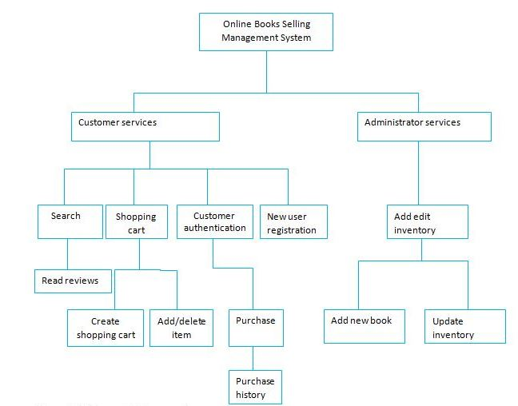

Figure 2.1: Conceptual framework

**Source**: Own design

## 2.3.1 Critical review

In first few pages I have seen and visited different e-books now I can to critically analyze our choice ,I can begin from Amazon which is the best e-book but for the first user , is a bit confusing ,it requires a long time for learning how to use it, beside contents in purchase process a user can read or download book online .About BooksYard this site gives the books freely which is good idea but the books they share are not complete and the site doesn’t provide search to all pages, this site is insecure too as someone can get any document without any authentication asked..

Finally I jump on Sribd which online share documents in excel format and other format only one issue of it is slow for navigation which causes waste of time.

## 2.3.2 Summary

This chapter was concerned about literature review with the design and functionality of the system. The design of the system is very user friendly and it is according to the modern web standards. The system was built by keeping in mind the requirements of company. The system is easy to use both for customers and the staff at company. System is working according to the requirements of company and also it is secure to use. System is highly flexible and adding new features and modules is very easy. Customers can easily view their orders status and they can easily manage their orders. The system is secure and provides books by cost of money, the users will get the book from store, they will not download soft copy after purchase process .The administrator control panel has options for administrators to manage orders and the overall system through a GUI and they don’t need to edit any code files. So changing the system setting and the look of pages is also very easy and require no high skills and finally the system is designed they way user will be able to search for books at any page he/she visits.

## CHAPTER THREE

## 3.0. RESEARCH DESIGN AND METHODOLOGY

## 3.1. Introduction

Methodology is broad [principles](http://www.businessdictionary.com/definition/principles.html) or [rules](http://www.businessdictionary.com/definition/rule.html) from which specific [methods](http://www.businessdictionary.com/definition/method.html) or [procedures](http://www.businessdictionary.com/definition/procedure.html) may be derived to interpret or solve different [problems](http://www.businessdictionary.com/definition/problem.html) within the [scope](http://www.businessdictionary.com/definition/scope.html) of a particular [discipline](http://www.businessdictionary.com/definition/discipline.html). Unlike an [algorithm](http://www.businessdictionary.com/definition/algorithm.html), a methodology is not a [formula](http://www.businessdictionary.com/definition/formula.html) but a set of [practices](http://www.businessdictionary.com/definition/practice.html).

Research methods refer to a number of ways of arriving at the knowledge regarding that research. Different approaches are used in software development process, such as waterfall, prototyping, spiral, etc. The methodology for software development process model that will be used in this project is waterfall model.

## 3.2. Data collection

Data collection is the process of gathering and [measuring](http://en.wikipedia.org/wiki/Measuring) information on variables of interest. The goal for all data collection is to capture quality evidence that then translates to rich data analysis and allows the building of a convincing and credible answer to questions that have been posed. For our project we used it to collect our data in order to achieve our objective we are going to explain it in the following way.

## 3.3. Documentation study technique

This kind of Technique allows the owner to consult different documents like Books in the Library and the notes of class and also others documents related to this Project. Concerning this technique to use it was very difficult to get the hard copy talk about online book selling coding but I consulted some Online Books And documents.

## 3.2.2 Techniques of investigation

To understand deeply the requirements and the problem domain, some techniques will help to achieve the aim of this work. The main techniques used are “interview” and “observation”.

## 3.2.3. Interview

An interview is a conversation between two or more people where questions are asked by the interviewer to elicit facts or statements from the interviewee. Interviews are a standard part of qualitative research.

# 3.2.3.1. Types of Interview **Structured or formal interview,** the researcher works through a questionnaire or Interview schedule as part of a social survey. Like the postal questionnaire, all respondents are exposed to the same set of questions. Positivists like this type of interview because they produce large amounts of factual information very cheaply and quickly compared with the unstructured interview and observation.

An interviewer can explain the questionnaire, thus reducing the possibility of non-response and ask for clarification of vague responses. An interviewer can observe the social context in which answers are given, e.g. the facial expression, tone of voice, body language, status, etc., of the respondent.

**The unstructured interview:** Interpreters argue that research should focus on the respondent’s view of the world through the use of unstructured interviews (sometimes known as ‘guided conversations’). This method involves the interviewer informally asking open-ended questions about a topic and allowing the respondent to respond freely and in depth.

They are flexible because the conversation is not constrained by fixed questions. This may generate more valid information (especially if the respondent can see their input is valued) and

Allows for probing of deeper meanings.

## 3.2.4. Observation

Observation is a systematic data collection approach. Researchers use all of their senses to examine people in natural settings or naturally occurring situations. Observation of a field setting involves: prolonged engagement in a setting or social situation.

## 3. 3. Software Development Process Model

The development models are the various processes or methodologies that are being selected for the development of the project depending on the project’s aims and goals. There are many development life cycle models that have been developed in order to achieve different required objectives. The models specify the various stages of the process and the order in which they are carried out.

A lot of different approaches are being used in software development process, such as waterfall, prototyping, spiral, and rapid application development (RAD) and so on.

## 3.3.1 Waterfall Model

The Waterfall Model was first Process Model to be introduced. It is also referred to as a linear-sequential life cycle model.  It is very simple to understand and use.  In a waterfall model, each phase must be completed fully before the next phase can begin. In this model the testing starts only after the development is complete. In **waterfall model phases** do not overlap.

The waterfall model is a sequential software development model in which development is seen as flowing steadily downwards (like a waterfall) through the phases of requirements analysis, design, implementation, testing (validation), integration, and maintenance.

**Waterfall Life Cycle Model**

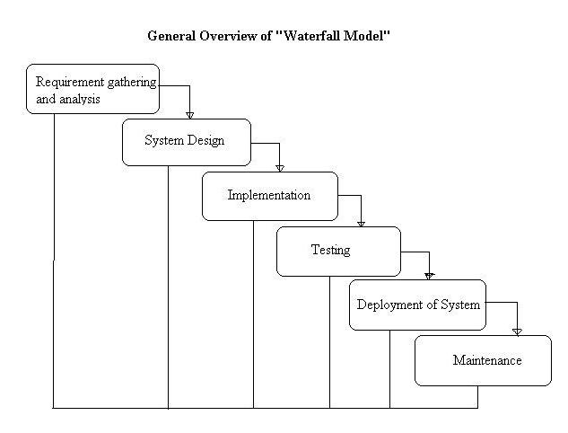

Figure 3.1: Waterfall model

Source: Sanjay Agal, 2013

## 3.3.1.0. Phases of waterfall model

## 3.3.1.1. Requirements Definition

This the important and crucial phase where the developer sit as a team and plan all things required to accomplish a task or the needed tools finish the project. By Specificities the problem and the desired service objectives (goals) and the constraints also are identified.

## 3.3.1.1.2. Design phase

This phase looks at how the software will be built and how the system will operate with particular emphasis on hardware, software, network infrastructure and user interface.

Here we have two types of design to be considered:

Logical Design: logical design which includes the design of forms and reports, the design of the interface and the database design.

Physical Design: physical design which is concerned with designing the physical database, the programs and processes and the distributed systems.

## 3.3.1.1.3. Implementation and unit testing phase

Subsequent to receiving the system design documents, the work is shared into various modules and the real coding is commenced. The system is developed into small coding units. These units are later integrated in the subsequent phase. Every unit is tested for its functionality.

## 3.3.1.1.4. The integration system and testing phase

The modules that are divided into units are integrated into a complete system and tested for proper coordination among modules and system behaves as per the specifications. Once the testing is completed, the software product is delivered to the customer.

## 3.3.1.1.5. Operations and Maintenance phase

It is a never ending phase. Once the system is running in production environment, problems come up. The issues that are related to the system are solved only after deployment of the system. The problems arise from time to time and need to be solved; hence this phase is referred as maintenance.

## 3.3.2. Advantages of the Waterfall Model

* This model is simple and easy to understand and use.
* It is easy to manage due to the rigidity of the model – each phase has specific deliverables and a review process.
* In this model phases are processed and completed one at a time. Phases do not overlap.
* Waterfall model works well for smaller projects where requirements are very well understood.

## 3.3.3. Disadvantages of the Waterfall Model

* Once an application is in the [testing](http://istqbexamcertification.com/what-is-a-software-testing/) stage, it is very difficult to go back and change something that was not well-thought out in the concept stage.
* No working software is produced until late during the life cycle.
* High amounts of risk and uncertainty.
* Not a good model for complex and object-oriented projects.
* Poor model for long and ongoing projects

## 3.4. Organization of the project

This project will be divided into five chapters. The first chapter will be related to the general introduction of this project, it will contain the statement of the problem, project objectives, the scope of the project, the interests of the project and the organization of the work. The second chapter will deal with the theory concepts. The third chapter will deal with research methodology. The fourth chapter will provide the analysis, development and implementation of the project. The fifth chapter and the last one will be discussion, conclusion and recommendations.

## 3.5. System Specification

## 3.5.1. Hardware specification

* RAM size of 2GB or more
* HDD size with free space of 100GB or more
* Processor of 2.5GHZ

**3.5.2. Software specification**

* Computer operating system: Windows 7, 8 and 10
* Web browser: Opera mini, Google chrome, Mozilla Firefox
* Editors: sublime text
* Web server: XAMP
* Front Languages end: HTML ,CSS and Bootstrap

## 3.6. Functional requirements

In Software engineering and systems engineering, a functional requirement defines a function of a system or its component. A function is described as a set of inputs, the behavior, and outputs. As defined in requirements engineering, functional requirements specify particular results of a system.

## 3.6.1. Functional Requirements of Online Books selling Management System

1. System must be able to add/modify customer.
2. Customer must be able to view his/her personal details only.
3. System must be able to accept orders from the customer via email or online form.
4. Customer must be able to view his/her orders history.
5. Each customer must be able to view placed order status.
6. System must alert the shop for new orders.
7. System must generate pro forma and customer invoice against an order.
8. Customer should be able to validate and confirm their invoice.
9. Shop manager must be able to view order history of a customer.
10. Shop must be able to validate and manage customers order against payments.
11. System must store information related to shipment and banking for each order.
12. The system must guarantee secure access to the stored data, managing the permissions according to the user profile.
13. The system must support easy addition of functionalities and enhancements

## 3.7 Context (Level 0) Diagram

The Context Diagram shows the system under consideration as a single high-level process and then shows the relationship that the system has with other external entities (systems, organizational groups, external data stores, etc.).  Another name for a Context Diagram is a Context-Level Data-Flow Diagram .

System context diagrams show a system, as a whole and its inputs and outputs from/to external factors. According to Kossiakoff and Sweet (2011).System Context Diagrams... represent all external entities that may interact with a system... Such a diagram pictures the system at the center, with no details of its interior structure, surrounded by all its interacting systems, environments and activities.

## 3.7.1. Context Diagram

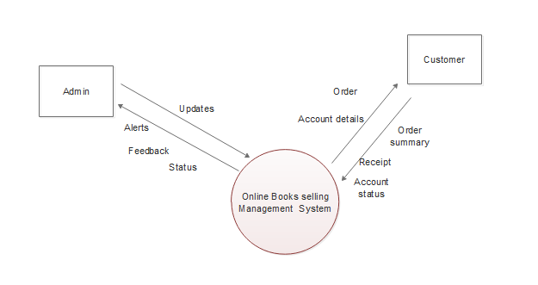

Figure 3.2: Context Diagram

**Source:** My own Design

## 3.8 Data Flow Diagram Level 1 and Level 2

Data Flow Diagrams show the flow of data from external entities into the system, and from one process to another within the system. There are four symbols for drawing a DFD:

1. Rectangles representing external entities, which are sources or destinations of data.

2. Ellipses representing processes, which take data as input, validate and process it and output it.

3. Arrows representing the data flows, which can either, be electronic data or physical items.

4. Open-ended rectangles or a Disk symbol representing data stores, including electronic stores such as databases or XML files and physical stores such as filing cabinets or stacks of paper.

## 3.8.1. Data Flow Diagram

Figure 3.3: Data Flow diagram

**Source:** My Own design

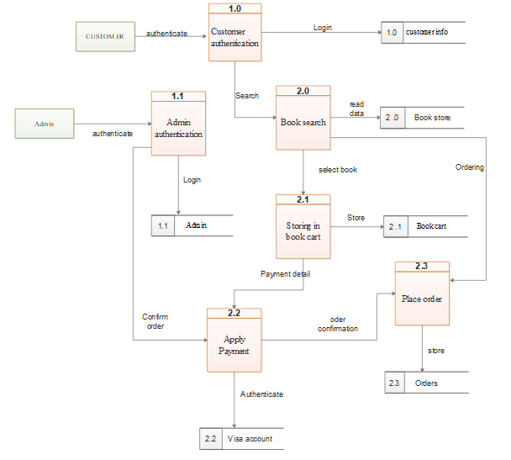

## 3.9 Entity relationship diagram

An entity relationship diagram (ERD) shows the relationships of entity sets stored in a database. An entity in this context is a component of data. In other words, ER diagrams illustrate the logical structure of databases. At first glance an entity relationship diagram looks very much like a flowchart. It is the specialized symbols, and the meanings of those symbols, that make it unique.

An ER diagram is a means of visualizing how the information a system produces is related. There are five main components of an ERD:

* Entities, which are represented by rectangles. An entity is an object or concept about which you want to store information.



* **Actions**, which are represented by diamond shapes, show how two entities share information in the database

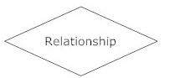

* **Attributes**, which are represented by ovals. A key attribute is the unique, distinguishing characteristic of the entity.

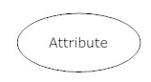

•**Connecting lines**, solid lines that connect attributes to show the relationships of entities in the diagram.

•**Cardinality** specifies how many instances of an entity relate to one instance of another entity. Ordinality is also closely linked to cardinality.

## 3.9.1 Entity relationship diagram

Figure 3.4: Entity relationship diagram

**Source:** My own design

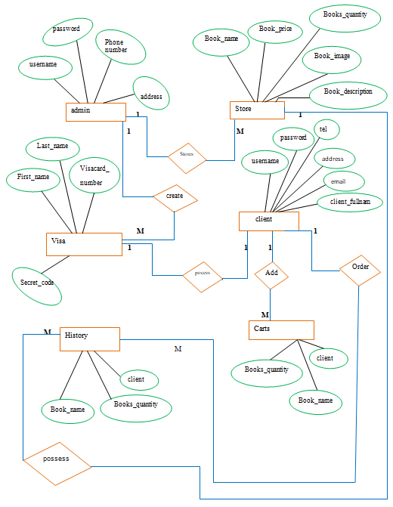

## 3.10 Physical Data Model (PDM)

Physical data model represents how the model will be built in the database. A physical database model shows all table structures, including column name, column data type, column constraints, primary key, foreign key, and relationships between tables. Features of a physical data model include:

* Specification all tables and columns.
* Foreign keys are used to identify relationships between tables.
* Denormalization may occur based on user requirements.
* Physical considerations may cause the physical data model to be quite different from the logical data model.
* Physical data model will be different for different RDBMS. For example, data type for a column may be different between MySQL and SQL Server.

The steps for physical data model design are as follows:

1. Convert entities into tables.
2. Convert relationships into foreign keys.
3. Convert attributes into columns.
4. Modify the physical data model based on physical constraints / requirements.

Figure 3.5: Physical Data Model

**Source**: My own Design

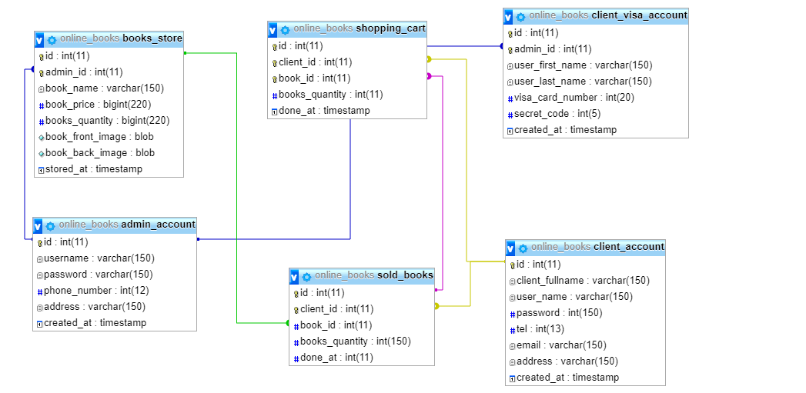

## 3.11 Data dictionary

A data dictionary is a file or a set of files that contains a database's metadata. The data dictionary contains records about other objects in the database, such as data ownership, data relationships to other objects, and other data. The data dictionary is a crucial component of any relational database.

Table 1: admin_account

Source: My own Design

|  |  |  |  |  |  |
| --- | --- | --- | --- | --- | --- |
| Attribute | Type | constraints | Null | Default | Extra |
| id | Int(11) | PK | No |  | auto_increment |
| username | Varchar(150} |  | No |  |  |
| password | Varchar(150} |  | No |  |  |
| phone_number | Int(12) |  | No |  |  |
| address | Varchar(150) |  | No |  |  |
| created_at | timestamp |  | No | CURRENT_TIMES TAMP |  |

Table 2: books_store

Source:My own Design

|  |  |  |  |  |  |  |  |
| --- | --- | --- | --- | --- | --- | --- | --- |
| Attribute | | Type | constraints | Null | Default | Extra | Links to |
| Id | | Int(11) | PK | No |  | auto_increment |  |
| admin_id | | Int(11) | FK | No |  |  | ->  admin_account.id  ON UPDATE  CASCADE  ON DELETE  CASCADE |
| book_name | | varchar(150} |  | No |  |  |  |
| book_price | | bigint(220) |  | No |  |  |  |
| book_quantity | | bigint(220) |  | No |  |  |  |
| book_front_image | | Blob |  | No |  |  |  |
| book_back_image | | Blob |  | No |  |  |  |
| stored_at | timestamp | |  | No | CURRENT_TIMES TAMP |  |  |

Table 3: client_account

**Source:** My own Design

|  |  |  |  |  |
| --- | --- | --- | --- | --- |
| Attribute | Type | Constraints | Null | Default |
| id | Int(11) | PK | No |  |
| client_fullname | Varchar(150) |  | No |  |
| password | Varchar(150) |  | No |  |
| tel | Int(13) |  | No |  |
| email | Varchar(150) |  | No |  |
| address | Varchar(150) |  | No |  |
| created_at | timestamp |  | No | CURRENT_TIMES TAMP |

Table 4: client_visa_account

**Source:** My own Design

|  |  |  |  |  |  |  |
| --- | --- | --- | --- | --- | --- | --- |
| Attribute | Type | Constraints | Null | Default | Extra | Links to |
| id | Int(11) | PK | No |  | auto_increment |  |
| admini_id | Int(11) | FK | No |  |  | ->  admin_account.id  ON UPDATE  RESTRICT  ON DELETE  RESTRICT |
| user_first_name | Varchar(150) |  | No |  |  |  |
| user_last_name | Varchar(150) |  | No |  |  |  |
| visa_card_number | Int(20) |  | No |  |  |  |
| secret_code | Int(5) |  | No |  |  |  |
| created_at | Timestamp |  | No | CURRENT_TIMES TAMP |  |  |

Table 5: shopping_cart

**Source:** My own Design

|  |  |  |  |  |  |  |
| --- | --- | --- | --- | --- | --- | --- |
| Attribute | Type | Constraints | Null | Default | Extra | Links to |
| id | Int(11) | PK | No |  | auto_increment |  |
| client_id | Int(11) | FK | No |  |  | ->  client_account.id  ON UPDATE  CASCADE  ON DELETE  CASCADE |
| book_id | Int(11) | FK | No |  |  | ->  sold_books.id  ON UPDATE  CASCADE  ON DELETE  CASCADE |
| books_quantity | Int(11) |  | No |  |  |  |
| done_at | Timestamp |  | No | CURRENT_TIMES TAMP |  |  |

Table 6: sold_books

**Source:** My own Design

|  |  |  |  |  |  |  |
| --- | --- | --- | --- | --- | --- | --- |
| Attribute | Type | Constraints | Null | Default | Extra | Links to |
| id | Int(11) | PK | No |  | auto_increment |  |
| client_id | Int(11) | FK | No |  |  | ->  client_account.id  ON UPDATE  CASCADE  ON DELETE  CASCADE |
| book_id | Int(11) | FK | No |  |  | ->books_store.id  ON UPDATE  RESTRICT  ON DELETE  RESTRICT |
| books_quantity | Int(150) |  | No |  |  |  |
| done_at | Int(11) |  | No |  |  |  |

## 3.12 Tools and languages to be used in software development

## 3.12.1. JavaScript

Is a cross-platform, object-oriented scripting language. It is a small and lightweight language. Inside a host environment (for example, a web browser), **JavaScript** can be connected to the objects of its environment to provide programmatic control over them. With the logic of JavaScript you can build an application with **Node**.**js** which is a platform built on Chrome's JavaScript runtime for easily building fast, scalable network applications. **Node**.**js uses** an event-driven, non-blocking I/O model that makes it lightweight and efficient, perfect for data-intensive real-time applications that run across distributed devices.

## 3.12.2. PHP

 Is a server-side scripting language designed for web development but also used as a general-purpose programming language? The most popular explanation of just what PHP stands for is "Hypertext Pre-processor".

PHP is a server scripting language, and a powerful tool for making dynamic and interactive Web pages. PHP is probably the most popular scripting language on the web. It is used to enhance web pages. If you have come across a web page that ends in PHP. PHP is known as a server-sided language. That's because the PHP doesn't get executed on your computer, but on the computer you requested the page from. The results are then handed over to you, and displayed in your browser.

## 3.12.3. MYSQL

MySQL is a freely available open source Relational Database Management System (RDBMS) that uses Structured Query Language (SQL). SQL is the most popular language for adding, accessing and managing content in a database. It is most noted for its quick processing, proven reliability, ease and flexibility of use.

MySQL is a [relational database management system](http://en.wikipedia.org/wiki/Relational_database_management_system) (RDBMS), and ships with no [GUI](http://en.wikipedia.org/wiki/Graphical_user_interface) tools to administer MySQL databases or manage data contained within the databases. Users may use the included [command line](http://en.wikipedia.org/wiki/Command_line) tools, or use MySQL "front-ends", desktop software and web applications that create and manage MySQL databases, build database structures, back up data, inspect status, and work with data records. The official set of MySQL front-end tools, [MySQL Workbench](http://en.wikipedia.org/wiki/MySQL_Workbench) is actively developed by Oracle, and is freely available for use.

## 3.12.4. XAMP

Is a free and open source cross-platform web server solution stack package, consisting mainly of the Apache HTTP Server, MySQL database, and interpreters for scripts written in the PHP and Perl programming languages.